***OOP LAB TASK # 13***

***Name: Shahmeer khan.***

***Class ID: 106278.***

***Student ID: 12113.***

***TASK:***

***Question no. 1:***

***Inputted Code:***

using System;

using System.Collections.Generic;

using System.Linq;

using System.Text;

using System.Threading.Tasks;

namespace workk

{

class Program

{

static void Main(string[] args)

{

Console.WriteLine("OOP LAB TASK 13:");

Console.WriteLine("Question no. 1:");

Engine m_Engine = new Engine();

Wheel m_Wheel = new Wheel();

Order order = new Order(m_Engine);

order.order();

Car car = new Car(m_Engine, m_Wheel);

car.Driver(50, 4);

Console.ReadKey();

}

}

class Order

{

private Engine m_Engine;

public Order(Engine eng)

{

m_Engine = eng;

}

public void order()

{

Console.WriteLine("\nYEah Yeah the order thing.....");

Console.WriteLine("dude you literally ordering a car engine???? you think it's a thing to eat???");

}

}

class Car

{

private Engine m_Engine;

private Wheel m_Wheel;

public Car(Engine eng, Wheel wh)

{

m_Engine = eng;

m_Wheel = wh;

}

public void Driver(int a, int b)

{

Console.WriteLine("\nOk The Car thing.\nCar Started!!!!");

m_Engine.Starts(a);

m_Wheel.Wheels(b);

Console.WriteLine("Car is moving!!!!!");

}

}

class Engine

{

public void Starts(int diesel)

{

Console.WriteLine("Engine Starts at " + diesel + " Litres deisel");

}

}

class Wheel

{

public void Wheels(int wheels)

{

Console.WriteLine("Car has " + wheels + " wheels.");

}

}

}

***Output:***

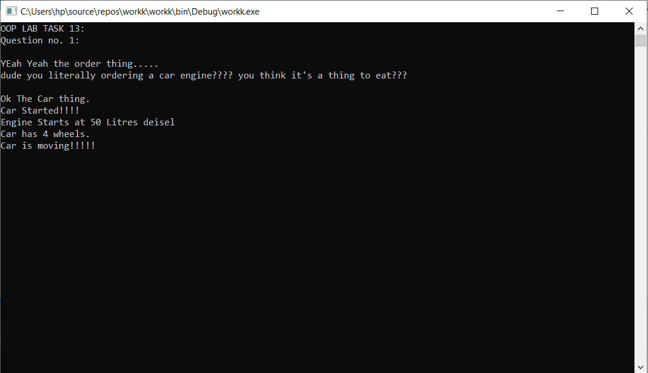

***Question no. 2:***

***Inputted Code:***

using System;

using System.Collections.Generic;

using System.Linq;

using System.Text;

using System.Threading.Tasks;

namespace workk

{

class Program

{

static void Main(string[] args)

{

Console.WriteLine("OOP LAB TASK 13:");

Console.WriteLine("Question no. 2:");

Person King_Shark = new Person();

Console.ReadKey();

}

}

public class Person

{

private Hand m_Hand = new Hand();

private Leg m_Leg = new Leg();

public Person()

{

Console.WriteLine("\nKing Shark is a Shark.");

m_Leg.leg();

m_Hand.hand();

}

}

public class Leg

{

public void leg()

{

Console.WriteLine("LLEEGGGG - King Shark");

}

}

public class Hand

{

public void hand()

{

Console.WriteLine("HAANNNDD - King Shark");

}

}

}

***Output:***

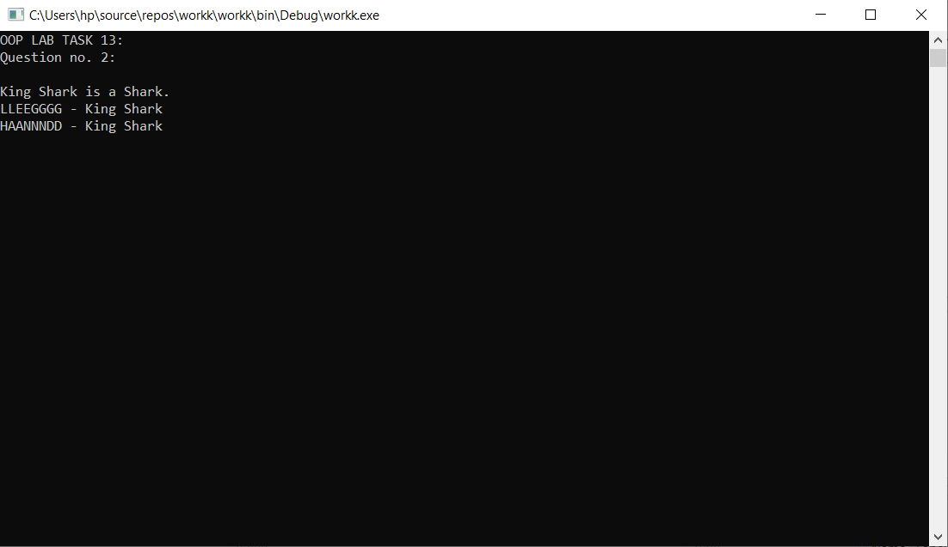***Question no. 3:***

***Inputted Code:***

using System;

using System.Collections.Generic;

using System.Linq;

using System.Text;

using System.Threading.Tasks;

namespace workk

{

class Program

{

static void Main(string[] args)

{

Console.WriteLine("OOP LAB TASK 13:");

Console.WriteLine("Question no. 3:");

HRManager HR = new HRManager("Chumpak Laal");

Contract ct = new Contract("4/17/2021", "Permanent");

HR.Contract_Details(ct);

Console.ReadKey();

}

}

class Contract

{

public string startDate;

public string contractType;

public Contract(string sd, string ct)

{

this.startDate = sd;

this.contractType = ct;

}

}

class HRManager

{

private string Name;

public HRManager(string HRMname)

{

this.Name = HRMname;

}

public void Contract_Details(Contract CT)

{

Console.WriteLine("\nHR-Manager Name: " + Name + "\nContract Start Date: " + CT.startDate + "\nContract-Type: " + CT.contractType);

}

}

}

***Output:***

